Setup for Java Programming with Android Studio

Where do you start? Important detailed instructions for installation can be found here:

https://github.com/ftctechnh/ftc_app

Go to => doc => tutorial => FTCTraining_Manual.pdf
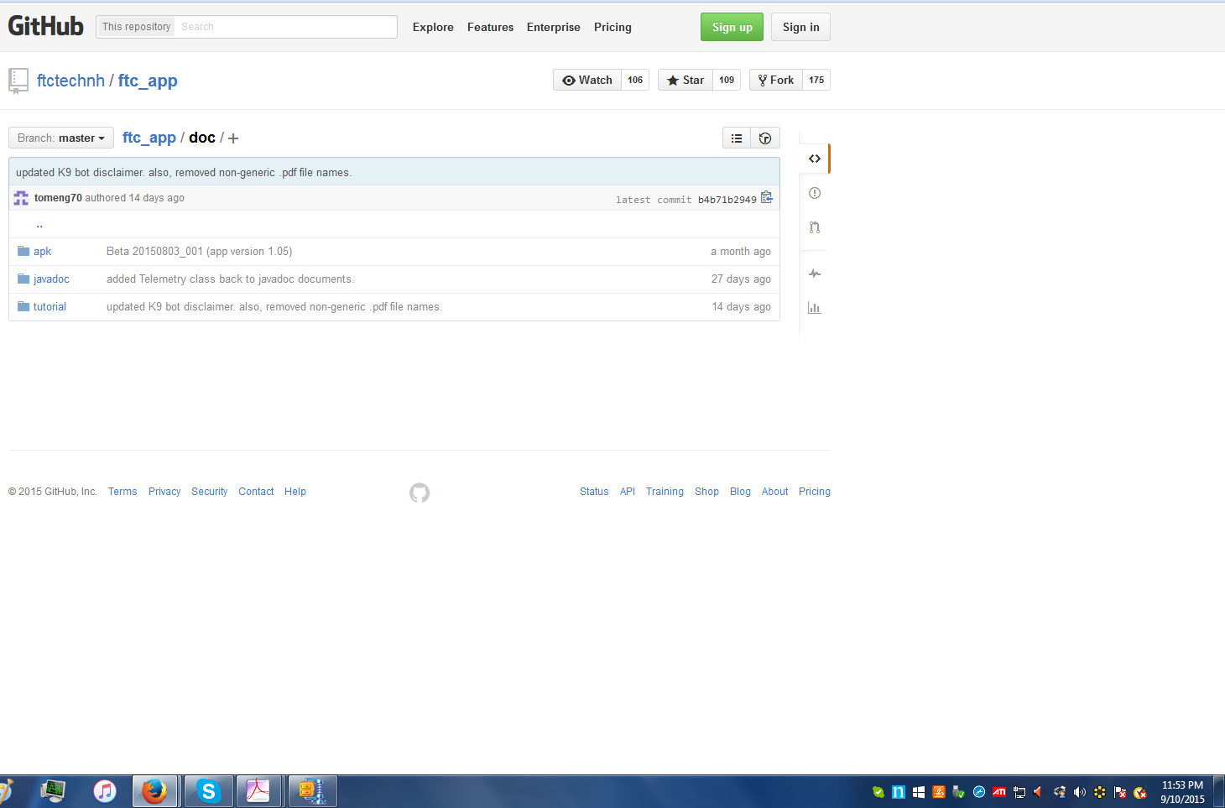

The highlights are captured below. You will need the latest Java JDK, Android Studio and FTC SDK. Git is optional.

a. Java JDK (Java Development Kit) - Required

Download and install the latest Java JDK from here (note: later version than the FTCTraining Manual v0_95.docx! You want the latest!):

www.oracle.com/technetwork/java/javase/downloads/index.html

x86 for 32 bit
x64 for 64 bit

b. Android Studio IDE (Integrated Development Environment) - Required

Download and install Android Studio from here: http://developer.android.com/sdk/index.html

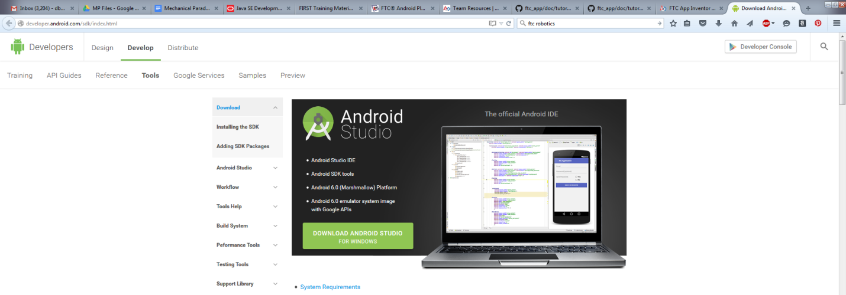

Select the big, green button then follow the install instructions.

c. FTC SDK (Software Development Kit) - Required

Download the "FTC SDK" from GitHub at https://github.com/ftctechnh/ftc_app

Important instructions

Launch Android Studio

On the Startup screen, select Import Project (Eclipse, ADT, Gradle, etc)

Select Configure

Select the SDK Manager

Check the boxes for API 21 SDK Platform and Google APIs, and Extras Google USB Driver

Click Install Packages and agree to License Agreements

Go back to the startup screen and select Import Project (Eclipse, ADT, Gradle, etc)

Navigate to and select the build.gradle included within the downloaded files

(When the process completed I had an error that I needed to resolve at the bottom of the screen. If this shows up for you, just do what it tells you to. It should work.)

If everything was successful, on the top left there should be a folder that says FTCRobotController. If not, refer to the FTCTraining Manual contained within ftc_app-master\doc\tutorial

(Some of the steps above I had to determine myself. If you have errors that you cannot resolve, I found answers on the stackoverflow forums to be rather useful. This made the software work for me, so you shouldn’t need it.)

d. Git (Optional)

Install Git from here: http://git-scm.com/downloads

